Cloud documentation:

ASHWIN: Research and cloud support

* Compare Azure and AWS to determine the best fit for our use case( 1 week)
* Study in brief the different resources available in the platform and in detail the resources that would be used for this project (By tuesday week)
* Test deploy the required resources (Data lake, PostrgreSQL DB, Data Factory) and learn its functionalities
* Create dummy scripts and trigger them using data factory peipelines and assess their effectiveness in data retrieval and storage
* Research about ways to connect the instance of PostgreSQL DB to the front-end web application and test it
* **NEEDED Snapshot of data, the raw data from different apis, and what the Visualization team aims to use as a tool for the visualization**

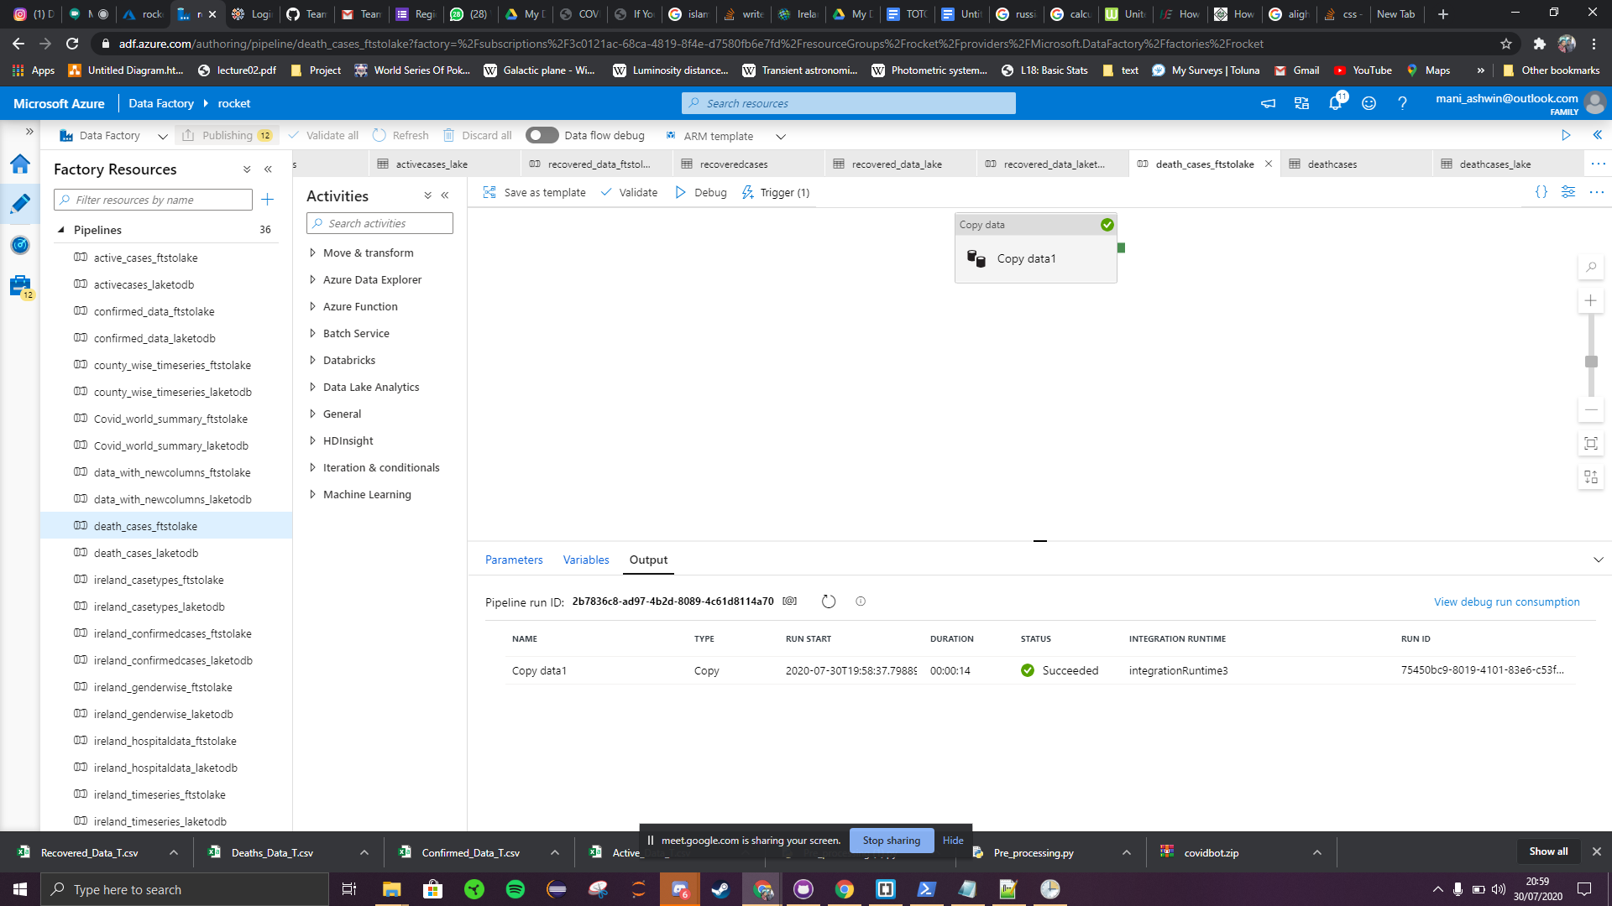

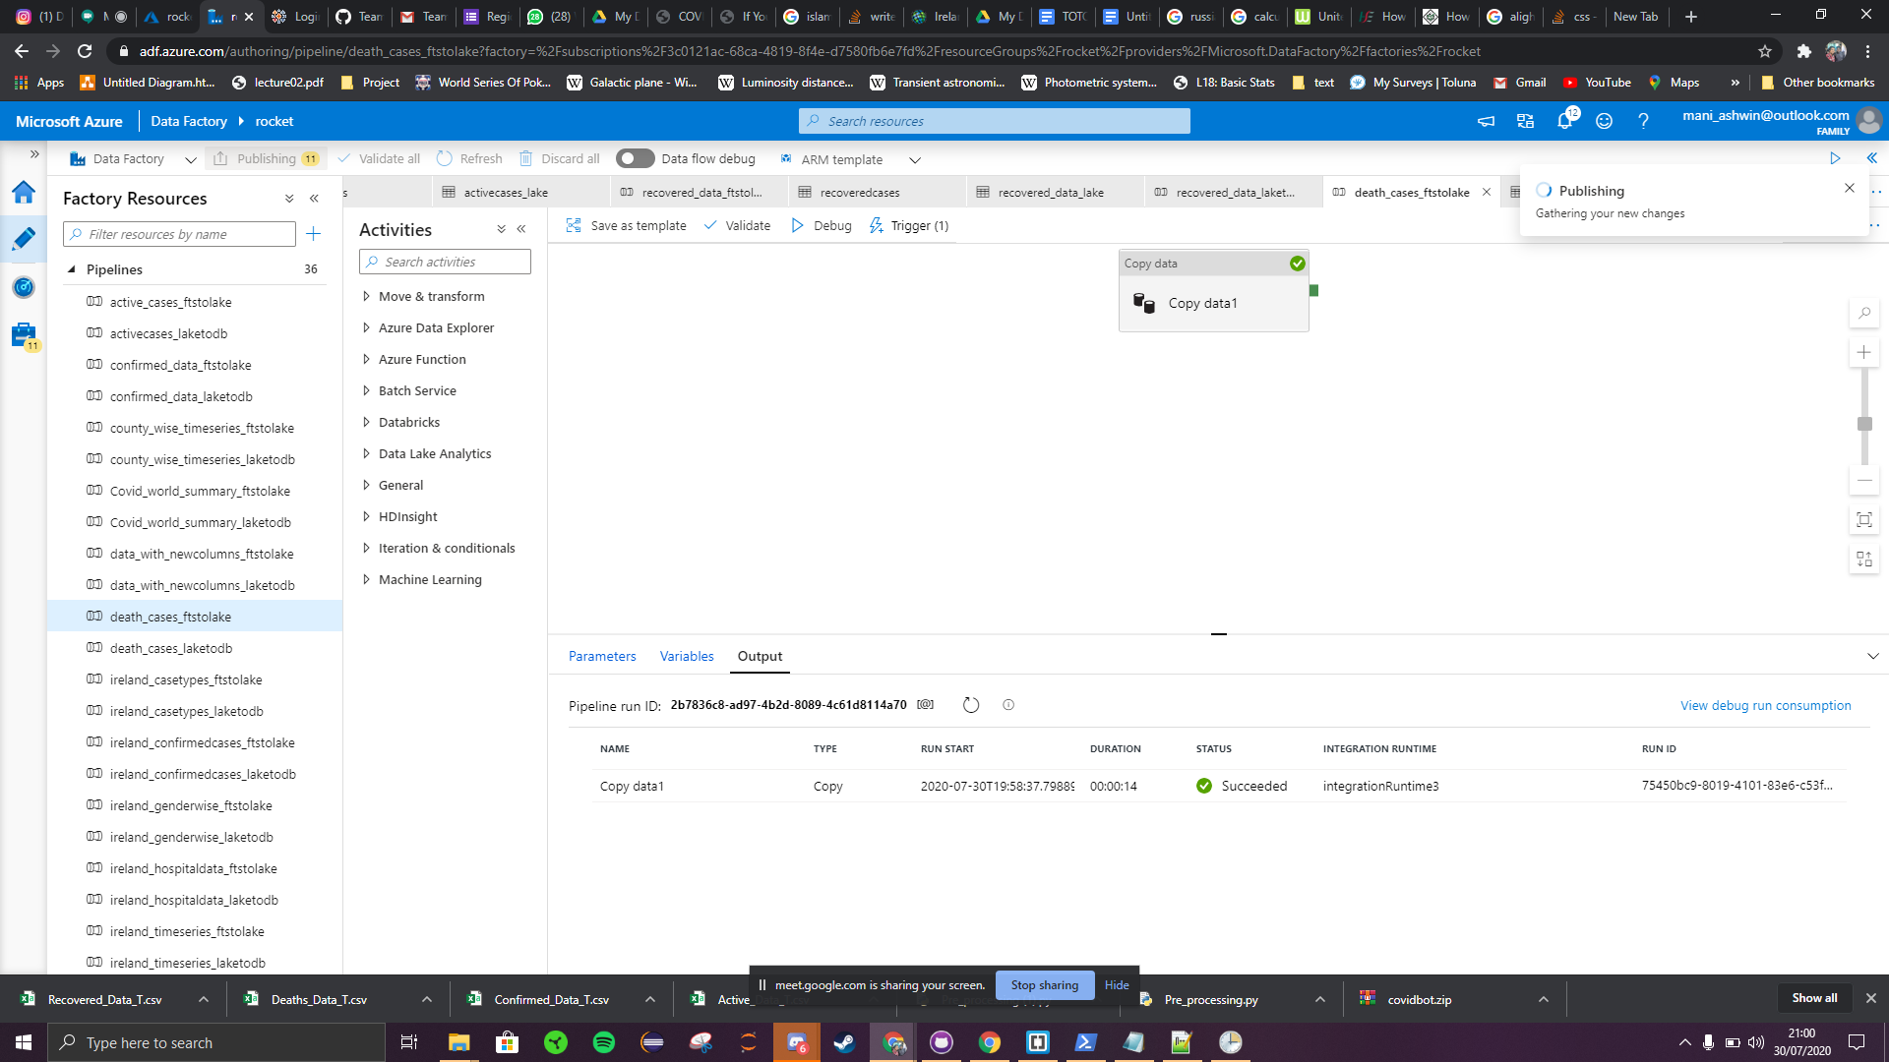

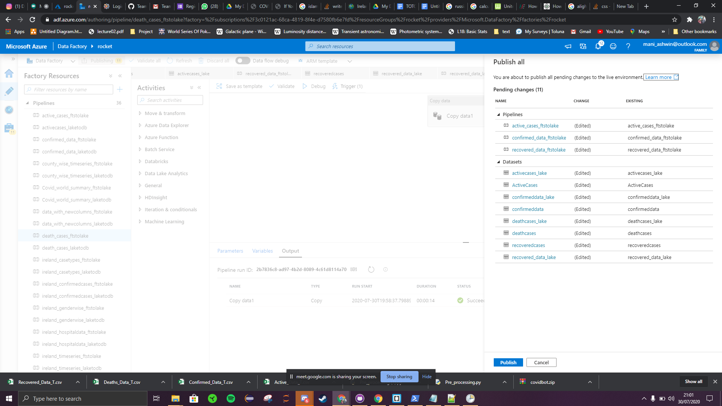

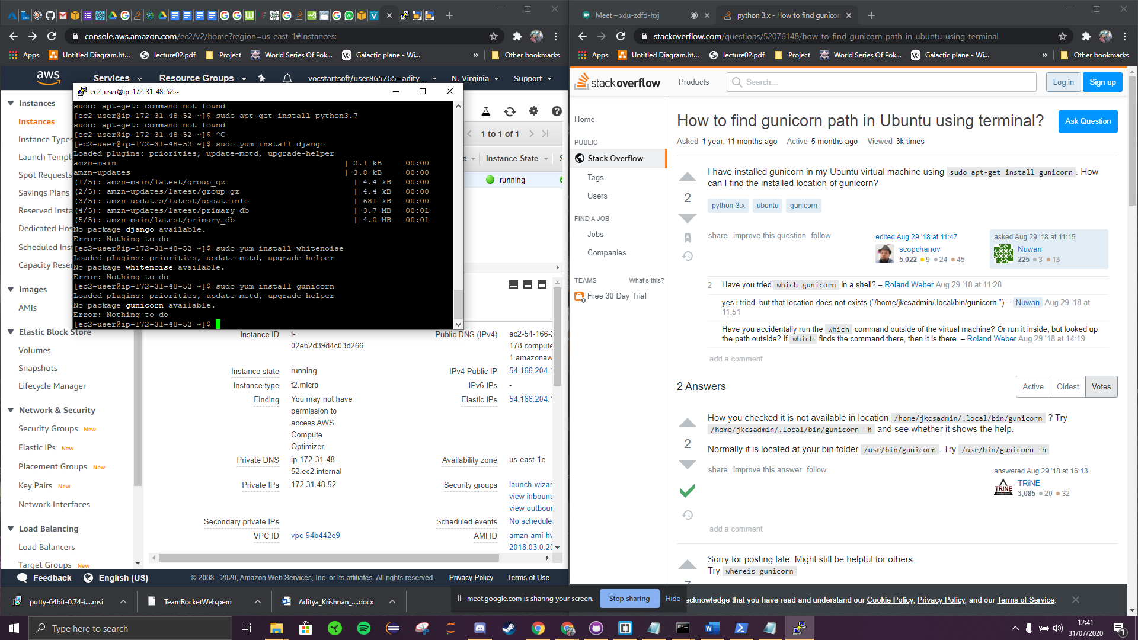

<https://www.guru99.com/creating-amazon-ec2-instance.html>